**A Project Report On**

**REAL-TIME FACEMASK DETECTION**

Project report submitted in partial fulfilment of requirement for the

Award of degree of

**BACHELOR OF SCIENCE**

(Mathematics, Physics and Computer Science)

**Submitted by**

P. SUDEER 3rd BSc MPCs (2018-1903052)

S. HEMA SAI 3rd BSc MPCs (2018-1903056)

V. PRABHAKAR 3rd BSc MPCs (2018-1903027)

**Under the esteemed guidance of**

**Sri .B. GURUNADHA RAO Sri .K KRISHNA KUMAR**

 **Lecturer in-charge Head of the Department**

***Department of Computer Science***

# GAYATRI VIDYA PARISIHAD

**DEGREE AND P.G. COURSES (AUTONOMOUS)**

**(Affiliated to Andhra University)**

**M.V.P. Colony, Visakhapatnam-17**

# GAYATRI VIDYA PARISIHAD

**DEGREE AND P.G. COURSES (AUTONOMOUS)**

**(Affiliated to Andhra University)**

**M.V.P. Colony, Visakhapatnam-17**



# CERTIFICATE

This is to certify that the project report titled **“REAL-TIME FACEMASK DETECTION”** submitted by **“P. Sudeer, S. Hema Sai, V. Prabhakar”** in partial fulfilment of the requirement for the award of the Degree of the Computer Applications at **Department of Computer Science,** Gayatri Vidya Parishad College for Degree and P.G Courses(A), Visakhapatnam is bonafide record of the work done by them at (G.V.P College for Degree and PG Courses(A),M.V.P colony) under my supervision*.*

**INTERNAL GUIDE HEAD OF THE DEPARTMENT** (Sri.B.Gurunadha Rao) (Sri.K.Krishna Kumar)

**EXTERNAL EXAMINER**

ACKNOWLEDGEMENT

In the present world of competition there is a race of existence in which those are having will to come forward succeed. Project is like a bridge between theoretical and practical working. With this willing I joined this particular project. First of all, I would like to thank the supreme power Computer Science Department who is obviously the one has always guided me to work on the right path of life. Without their grace this project could not become a reality. Next to them are my parents, whom I am greatly indebted for me, brought up with love and encouragement to this stage.

I am feeling oblige in taking the opportunity to sincerely thanks to our Principal **Prof.S.Rajini** madam and special thanks to my worthy Director **Dr.I.S.Pallavi** madam. I am highly obliged in taking the opportunity to sincerely thanks to Head of the department **Sri.K.Krishna Kumar** sir, and our project guide **Sri.B.Gurunadha** **Rao** sir & all the staff members of computer department for their generous attitude and friendly behaviour.

Lastly, We would also like to thank all those people whose names may not have been appeared here but whose contribution has not gone un-noticed. We also personally very thankful to them.

We have grown both personally and academically from this experience and we are very grateful for having the opportunity to conduct this study.

**Contents**

1. **Abstract 1**
2. **Introduction 2-3**
3. **Recent work 4-5**
4. **Methodology 6-8**
5. **Proposed workflow**
6. **Machine learning architecture**
7. **Image processing**
8. **Dataset collection**
9. **Architecture development**
10. **Alert generation**
11. **System requirements 9**
12. **Python version**
13. **Operating system**
14. **Pip**
15. **Hardware requirements**
16. **Required libraries 10**
17. **TensorFlow 11-14**
18. **TensorFlow origins and releases**
19. **Applications of TensorFlow**
20. **Keras 15-18**
21. **Overview of keras**
22. **Features**
23. **Benefits**
24. **Prerequisites**
25. **Python**
26. **Imutilis 19-23**
27. **Installing**
28. **Translation**
29. **Rotation**
30. **Resizing**
31. **Skeletonization**
32. **NumPy 24-27**
33. **Audience**
34. **Prerequisites**
35. **Operations using NumPy**
36. **Building from source**
37. **OpenCv 28-32**
38. **Object classification**
39. **Object identification**
40. **History**
41. **Prerequisite**
42. **Audience**
43. **Matplotlib 33-35**
44. **Audience**
45. **Prerequisites**
46. **SciPy 36-39**
47. **Audience**
48. **Prerequisites**
49. **Scipy Sub-packages**
50. **Data structure**
51. **Face-Mask-Detection-Master 40**
52. **Dataset**
53. **With_Mask 41-43**
54. **Without_Mask**
55. **Face_Detector 44**

**10. Coding 45-65**

1. **Train_Mask_Detector.py**
2. **Detect_Mask_Video.py**

**11. Input & Output 66-67**

**12. Result analysis 68**

**13. Limitations and further works 69**

**14. Conclusion 70**

**15. Bibliography 71**

**ABSTRACT**

In the age of covid-19, face masks and social distancing have become very normal. In this project, we will introduce a machine learning project on real-time face mask detection with python programming language.

The technology behind the real-time face mask detection system is not new. It is a common example for face unlocking in smart phones.

The goal of this project is to create an image recognition system that understands how image classification works, and it should work with great accuracy. So that our model can be applied in the real-time situations. It will work by recognizing the boundaries of the face and predicting whether you are wearing a face mask or not in real-time.

In this project we used machine learning concepts and build a model using python programming language.

**INTRODUCTION**

A new strain of virus was identified in humans, known as novel coronavirus (nCoV), which was never previously been identified in humans. Coronaviruses (CoV) are a wide group of viruses which cause illness that range from basic colds to infections like Middle East Respiratory Syndrome (MERS) and Severe Acute Respiratory Syndrome (SARS). The first infected patient of coronavirus was found in December 2019. The habit of wearing face masks while stepping out is rising due to the COVID- 19 corona virus epidemic. Before Covid-19, masks were worn by people to protect their health from air pollution. Scientists have concluded that wearing face masks works on decreasing COVID-19 transmission. In 2020, the rapid spread of COVID-19 led the World Health Organization to declare COVID- 19 as a global pandemic. The virus spreads through close contact of humans and in crowded/overcrowded places. Among them cleaning hands, maintaining a safe distance, wearing a mask, refraining from touching eyes, nose, and mouth are the main, where wearing a mask is the simplest one. Unfortunately, people are not following these rules properly which is resulting in speeding the spread of this virus. The solution can be to detect the people not wearing mask and informing their authorities. the face mask detection is a technique to find out whether the person is wearing a mask or not. In medical applications Deep learning techniques are highly used as it allows 30 researchers to study and evaluate large quantities of data. Deep learning models have shown great role in object detection. These models and architectures can be used in detecting the mask on a face. Here we introduce a face mask detection model which is based on computer vision and deep learning. The proposed model can be integrated with computer or laptop cameras allowing it to detect people who are wearing masks and not wearing masks. The model has been put together using deep learning and classical machine learning techniques with OpenCV, tensor flow, keras, imutils, numpy, matplotlib and scipy. We have introduced a most suitable machine learning algorithm that yields the highest accuracy. The spread of COVID-19 virus has reduced but it is still not over. If everyone follows all the safety measures, then it can come to an end. This will help in lowering the cases to such a level that COVID19 virus can vanish from everywhere. The most recent works of face mask detection are described in Section II. Section III is the proposed methodology for developing the whole system. Section IV is the analysis of results obtained from the system. Section V is the conclusion part. And Lastly, the limitations of system with some potential further work is depicted in Section VI. In this project, we will introduce a machine learning project on real-time face mask detection with python programming language.

**RECENT WORK**

Sujatha and Chatterjee [1] proposed a model that could be useful to foresee the spread of COVID2019 by using linear regression, Multilayer perceptron and Vector autoregression model on the COVID-19 kaggle data to envision the epidemiological example of the malady and pace of COVID-2019 cases in India. Navares et al. [2] introduced an answer for the issue of anticipating every day medical clinic confirmations in Madrid because of circulatory and respiratory cases dependent on biometeorological markers. Cui and Singh created and applied the MRE hypothesis for month to month streamflow prediction with spectral power as a random variable. A system [4] that restrict the growth of COVID-19 by finding out people who are not wearing any facial mask in a smart city network where all the public places are monitored with Closed Circuit Television (CCTV) cameras. Firstly, CCTV cameras are used to capture real-time video footage of different public places in the city. From that video footage, facial images are extracted and these images are used to identify the mask on the face. Another model [5] for face detection using semantic segmentation in an image by classifying each pixel as face and non-face i.e. effectively creating a binary classifier and then detecting that segmented area. It works very well not only for images having frontal faces but also for non-frontal faces. The most helpful project for us, proposed [6] a method for automatic door access system using face recognition technique by using python programming and from OpenCV library Haar cascade method. Object Detection using Haar feature-based cascade classifiers is an effective object detection method proposed by Paul Viola and Michael Jones [7]. Another research [8] in which hybrid model using deep and classical machine learning for face mask detection is presented. A face mask detection dataset consists of with mask and without mask images, then using OpenCV to do real-time face detection from a live stream via webcam. Another tutorial [9], had two-phase COVID-19 face mask detector, detailing how computer vision/deep learning pipeline will be implemented. The trained COVID-19 face mask detector, will implement two more additional Python scripts used to detect COVID-19 face masks in images and detect face masks in real-time video streams.

**METHODOLOGY**

We have devised a smart framework for detecting facemask in this paper. As the cases of covid19 are decreasing maximum workplaces are opening with half or full employees. Even the education institutes are planning to be opened. For screening the people not wearing masks, this system can be installed in the entrances of enterprises, educational institutes, public and private offices. If the system detects a person’s face with no mask, it will warn that person has no mask with percentage. The block diagram of the developed framework is depicted.

**A. Proposed workflow**

We decided to build a very simple and basic machine model using TensorFlow with Keras library, OpenCV and some other libraries to detect if you are wearing a face mask to protect yourself. All the aspects of our work are described below.

**B. Machine learning architecture**

The machine learning architecture learns various important nonlinear features from the given samples. Then, this learned architecture is used to predict previously unseen samples.

**C. Image Processing**

OpenCV and some other libraries will detect the input from videocam. The images captured by the system's webcam required pre-processing before going to the next step. In the pre-processing step, the image is transformed into a grayscale image because the RGB color image contains so much redundant information that is not necessary for face mask detection. Then, we resized the images into (150x150) size to maintain uniformity of the input images to the architecture. Then, the images are normalized and after normalization, the value of a pixel resides in the range from 0 to 1. Normalization helped the learning algorithm to learn faster and captured necessary features from the images.

**D. Dataset Collection**

To train our machine learning architecture, we collected images. The architecture of the learning technique highly depends on dataset. Data from source[10] is collected for training and testing the model. Dataset contains images of faces only. It consists of about 3883 images in which 1915 images containing people with face masks and 1918 images containing people without face masks. For training purposes, these images of each class are utilized for training purposes.

**E. Architecture Development**

The learning model is based on OpenCV which is very useful for pattern recognition from images. Neural Network need to see data from both the classes. The network comprises an input layer, several hidden layers and an output layer. The hidden layers consist of multiple convolution layers. The features extracted by CNN are used by multiple dense neural networks for classification purposes. The architecture contains three pairs of convolution layers each 32 followed by one max pooling layer. The convolution layer contains 100 kernels of window size 3x3. Max pooling layer of window size 2x2. This layer will be aggregating the results from the previous convolution layer and will be picking the max value in that 2x2 window. It decreases the spatial size of the representation and thereby reduces the number of parameters. As a result, the computation is simplified for the network. The output of the convolution layers will be flattened and will be converted into a 1-D array. Then there is one dropout layer and two dense layers. The dropout layer prevents the network from overfitting by dropping out units. The dense layer comprises a series of neurons each of them learn nonlinear features. The flattened result this will be fed to the first dense layer of 50 nodes. Then finally second dense layer containing two nodes as there are two classes.

**F. Alert Generation**

The purpose of our system is to screen person not wearing face mask. The learning architecture generates result on the input image, classifying the image into mask or no mask classes. If a person is detected not wearing a mask then it warns that person to put on the mask. And if everyone is wearing a mask then they will be safe from the virus. In this way our system would help greatly to limit the growth of COVID-19.

**SYSTEM REQUIREMENTS**

**Python Version**

* + Python 3.6–3.9

**Operating System**

* Ubuntu 16.04 or later (64-bit)
* macOS 10.12.6 (Sierra) or later (64-bit) *(no GPU support)*
* Windows 7 or later (64-bit)

**Pip**

* pip 19.0 or later (requires manylinux2010 support)
  + macOS requires pip 20.3 or later

**Hardware Requirements**

* Ram – 1GB or above
* Webcam – Must and should

**REQUIRED LIBRARIES**

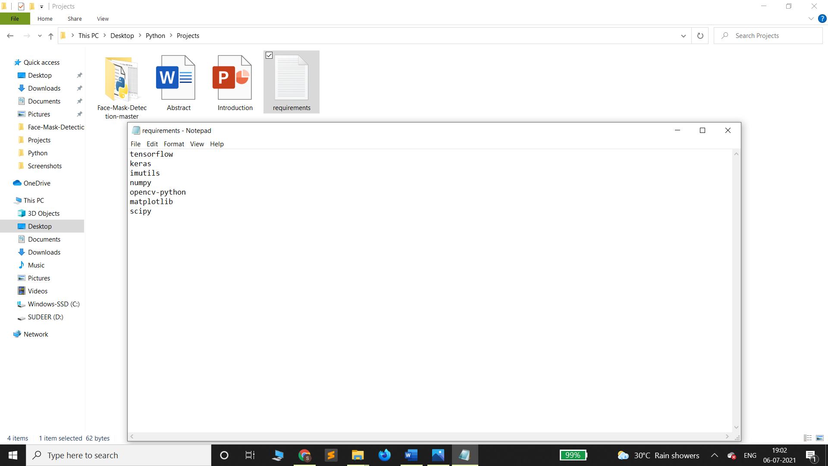

The required packages/libraries for implementing this python project are tensorflow, keras, imutils, numpy, opencv-python, matplotlib, scipy are explained below.

**TENSORFLOW**

TensorFlow is an open source framework developed by Google researchers to run [machine learning](https://searchenterpriseai.techtarget.com/definition/machine-learning-ML), [deep learning](https://searchenterpriseai.techtarget.com/definition/deep-learning-deep-neural-network) and other statistical and predictive analytics workloads. Like similar platforms, it's designed to streamline the process of developing and executing advanced analytics applications for users such as data scientists, statisticians and predictive modelers.

The TensorFlow software handles data sets that are arrayed as computational nodes in graph form. The edges that connect the nodes in a graph can represent multidimensional vectors or matrices, creating what are known as tensors. Because TensorFlow programs use a data flow architecture that works with generalized intermediate results of the computations, they are especially open to very large-scale parallel processing applications, with [neural networks](https://searchenterpriseai.techtarget.com/definition/neural-network) being a common example.

The framework includes sets of both high-level and low-level APIs. Google recommends using the high-level ones when possible to simplify data pipeline development and application programming. However, knowing how to use the low-level APIs -- called TensorFlow Core -- can be valuable for experimentation and debugging of applications, the company says; it also gives users a "mental model" of the machine learning technology's inner workings, in Google's words.

TensorFlow applications can run on either conventional [CPUs](https://whatis.techtarget.com/definition/processor) or higher-performance graphics processing units ([GPUs](https://searchvirtualdesktop.techtarget.com/definition/GPU-graphics-processing-unit)), as well as Google's own tensor processing units (TPUs), which are custom devices expressly designed to speed up TensorFlow jobs. Google's first TPUs, detailed publicly in 2016, were used internally in conjunction with TensorFlow to power some of the company's applications and online services, including its RankBrain search algorithm and Street View mapping technology.

In early 2018, Google furthered its external TensorFlow efforts by making the second generation of TPUs available to [Google Cloud Platform](https://searchcloudcomputing.techtarget.com/definition/Google-Cloud-Platform) users for training and running their own machine learning models. TensorFlow-based workloads are billed on a per-second basis; the Cloud TPU service initially was launched as a beta program with only "limited quantities" of the devices available for use, according to Google.

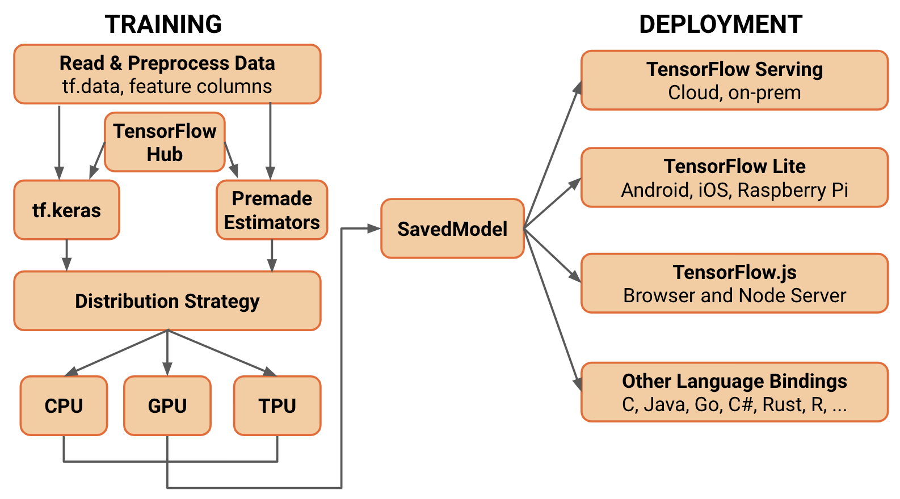

**TensorFlow origins and releases**

TensorFlow followed in the footsteps of a closed-source Google framework called DistBelief, which the company used internally to carry out unsupervised feature learning and deep learning applications based on extremely large neural networks and the [backpropagation algorithm](https://searchenterpriseai.techtarget.com/definition/backpropagation-algorithm).

DistBelief, which Google first disclosed in detail in 2012, was a testbed for implementations of deep learning that included advanced image and speech recognition, natural language processing, recommendation engines and predictive analytics.

TensorFlow differs from DistBelief in a number of ways. Because TensorFlow was designed to be able to work separately from Google's own computing infrastructure, its code was more easily portable for outside uses. It's also a more general machine learning framework that isn't as tightly focused on neural networks as DistBelief was. Moreover, it's designed to support faster configuration and to run against the high-level APIs.

In early 2017, TensorFlow reached Release 1.0.0 status. That version added a specialized debugger, a domain-specific compiler for TensorFlow graphs, [Docker](https://searchitoperations.techtarget.com/definition/Docker) container images for version 3 of the [Python](https://whatis.techtarget.com/definition/Python) programming language and an experimental Java API. Four more releases followed during the course of 2017; a TensorFlow Lite version optimized for use on mobile and embedded devices was also introduced as a developer preview. As of February 2018, TensorFlow was up to Release 1.6.0.

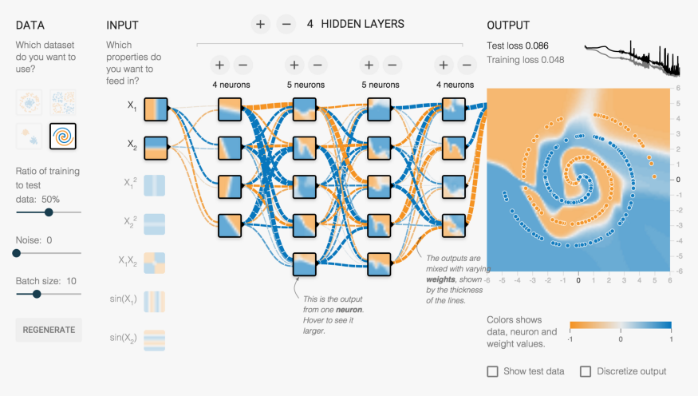

Deep learning Tensorflow concept

**Applications of TensorFlow**

For the most part, TensorFlow applications are advanced and large-scale AI undertakings in the realms of machine learning and deep learning. In powering Google's [RankBrain](https://whatis.techtarget.com/definition/RankBrain) machine learning system, TensorFlow has been employed to improve the information retrieval capabilities of the company's flagship search engine.

Google has also used the framework for applications that include automatic email response generation, image classification and optical character recognition, as well as a drug-discovery application that the company worked on with researchers from Stanford University.

Other companies listed on the TensorFlow website as users of the framework include Airbnb, Coca-Cola, eBay, Intel, Qualcomm, SAP, Twitter, Uber and Snapchat developer Snap Inc. Another user is STATS LLC, a sports consulting company that runs TensorFlow-based deep learning models to analyze things such as the movements of players during professional sports games.

TensorFlow-based deep learning has also been a part of experiments and tests involving one of the larger-scaled proposed innovations today, that is self-driving cars.

Some smaller-scale uses have been found, too. For example, a small Japanese farm uses TensorFlow to sort cucumbers based on their textures.

**KERAS**

Top of Form

Bottom of Form

Keras is an open source deep learning framework for python. It has been developed by an artificial intelligence researcher at Google named Francois Chollet. Leading organizations like Google, Square, Netflix, Huawei and Uber are currently using Keras. This tutorial walks through the installation of Keras, basics of deep learning, Keras models, Keras layers, Keras modules and finally conclude with some real-time applications.

This tutorial is prepared for professionals who are aspiring to make a career in the field of deep learning and neural network framework. This tutorial is intended to make you comfortable in getting started with the Keras framework concepts.

Before proceeding with the various types of concepts given in this tutorial, we assume that the readers have basic understanding of deep learning framework. In addition to this, it will be very helpful, if the readers have a sound knowledge of Python & Machine Learning.

Deep learning is one of the major subfield of machine learning framework. Machine learning is the study of design of algorithms, inspired from the model of human brain. Deep learning is becoming more popular in data science fields like robotics, artificial intelligence (AI), audio & video recognition and image recognition. Artificial neural network is the core of deep learning methodologies. Deep learning is supported by various libraries such as Theano, TensorFlow, Caffe, Mxnet etc., Keras is one of the most powerful and easy to use python library, which is built on top of popular deep learning libraries like TensorFlow, Theano, etc., for creating deep learning models.

## Overview of Keras

Keras runs on top of open source machine libraries like TensorFlow, Theano or Cognitive Toolkit (CNTK). Theano is a python library used for fast numerical computation tasks. TensorFlow is the most famous symbolic math library used for creating neural networks and deep learning models. TensorFlow is very flexible and the primary benefit is distributed computing. CNTK is deep learning framework developed by Microsoft. It uses libraries such as Python, C#, C++ or standalone machine learning toolkits. Theano and TensorFlow are very powerful libraries but difficult to understand for creating neural networks.

Keras is based on minimal structure that provides a clean and easy way to create deep learning models based on TensorFlow or Theano. Keras is designed to quickly define deep learning models. Well, Keras is an optimal choice for deep learning applications.

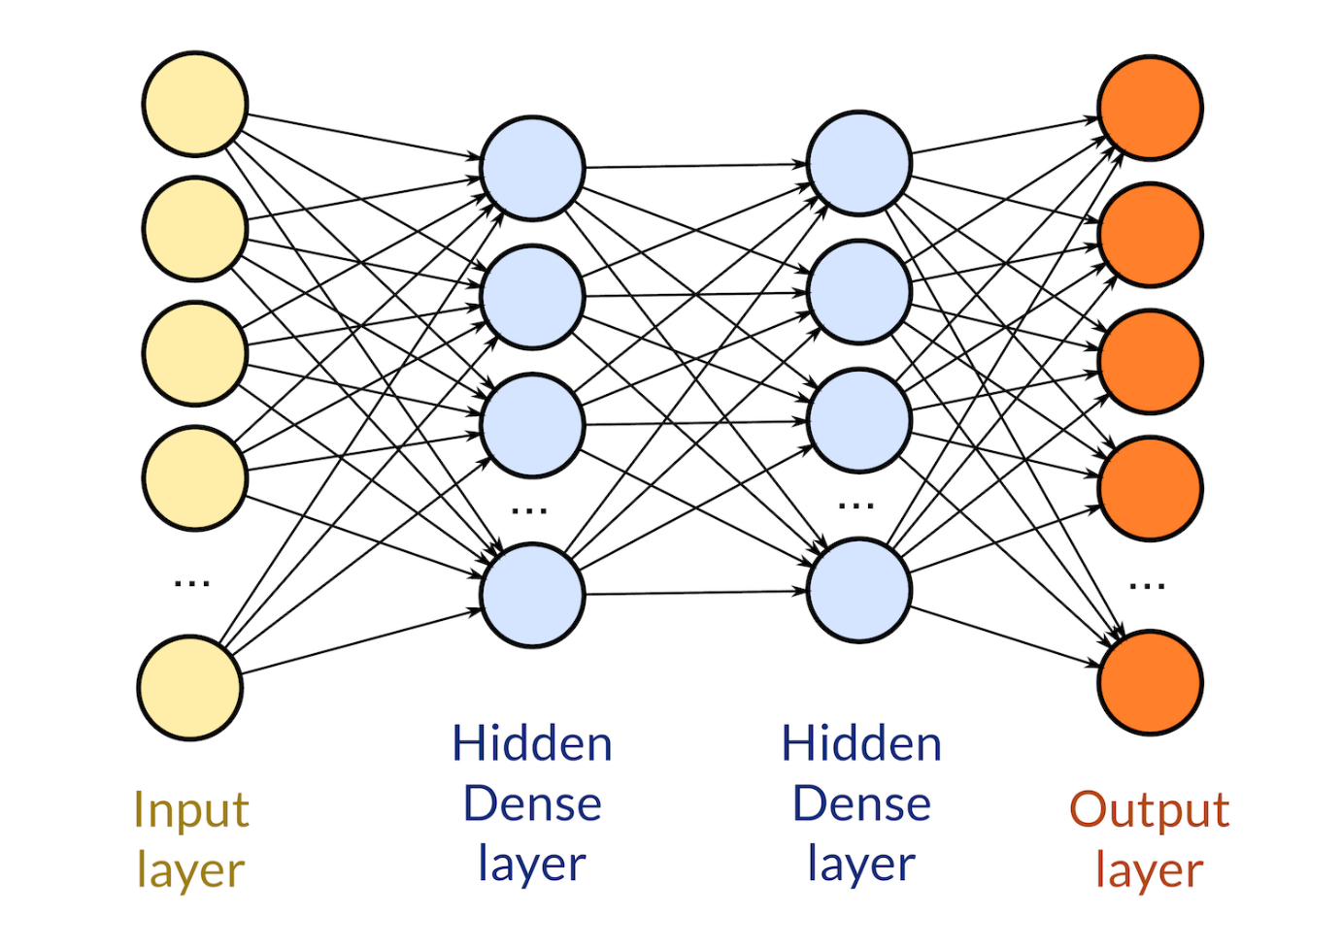

Input and output layers

## Features

Keras leverages various optimization techniques to make high level neural network API easier and more performant. It supports the following features −

* Consistent, simple and extensible API.
* Minimal structure - easy to achieve the result without any frills.
* It supports multiple platforms and backends.
* It is user friendly framework which runs on both CPU and GPU.
* Highly scalability of computation.

## Benefits

Keras is highly powerful and dynamic framework and comes up with the following advantages −

* Larger community support.
* Easy to test.
* Keras neural networks are written in Python which makes things simpler.
* Keras supports both convolution and recurrent networks.
* Deep learning models are discrete components, so that, you can combine into many ways.

This chapter explains about how to install Keras on your machine. Before moving to installation, let us go through the basic requirements of Keras.

**Prerequisites**

You must satisfy the following requirements −

* Any kind of OS (Windows, Linux or Mac)
* Python version 3.5 or higher.

**Python**

Keras is python based neural network library so python must be installed on your machine. If python is properly installed on your machine, then open your terminal and type python, you could see the response similar as specified below,

Python 3.6.5 (v3.6.5:f59c0932b4, Mar 28 2018, 17:00:18)

[MSC v.1900 64 bit (AMD64)] on win32

Type "help", "copyright", "credits" or "license" for more information.

>>>

As of now the latest version is ‘3.7.2’. If Python is not installed, then visit the official python link - [www.python.org](https://www.python.org/) and download the latest version based on your OS and install it immediately on your system.

**IMUTILIS**

A series of convenience functions to make basic image processing functions such as translation, rotation, resizing, skeletonization, and displaying Matplotlib images easier with OpenCV and both Python 2.7 and Python 3.

[PyPI](https://pypi.python.org/pypi), the Python Package Index repository is a wonderful thing. It makes downloading, installing, and managing Python libraries and packages a breeze.

This package includes a series of OpenCV + convenience functions that perform basics tasks such as translation, rotation, resizing, and skeletonization.

In the future we will (probably, depending on feedback in the comments section) be performing a detailed code review of each of the functions in the

imutils

 package, but for the time being, take a look at the rest of this blog post to see the functionality included in

imutils

 , then be sure to install it on your own system!

**Installing**

This package assumes that you already have [**NumPy**](http://www.numpy.org/) and [**OpenCV**](http://opencv.org/) installed (along with [**matplotlib**](http://matplotlib.org/), if you intend on using the

opencv2matplotlib

 function).

To install the the

imutils

 library, just issue the following command:

$ pip install imutils

**My imutils package: A series of OpenCV convenience functions**

Let’s go ahead and take a look at what we can do with the

imutils

 package.

## Translation

Translation is the shifting of an image in either the x or y direction. To translate an image in OpenCV you need to supply the (x, y)-shift, denoted as (tx, ty) to construct the translation matrix M:

**[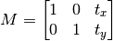](https://pyimagesearch.com/wp-content/uploads/2015/01/translation_eq.png)**

And from there, you would need to apply the

cv2.warpAffine

 function.

Instead of manually constructing the translation matrix M and calling

cv2.warpAffine

 , you can simply make a call to the

translate

 function of

imutils

## Rotation

Rotating an image in OpenCV is accomplished by making a call to

cv2.getRotationMatrix2D

 and

cv2.warpAffine

 . Further care has to be taken to supply the (x, y)-coordinate of the point the image is to be rotated about. These calculation calls can quickly add up and make your code bulky and less readable. The

rotate

 function in

imutils

 helps resolve this problem.

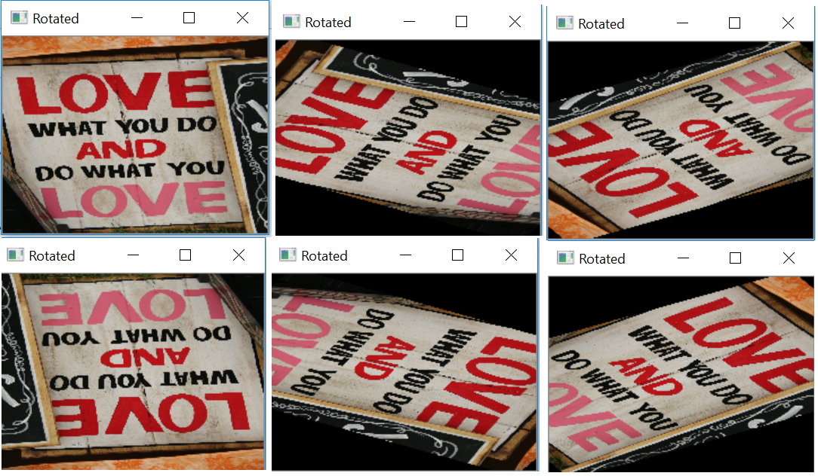

## Resizing

Resizing an image in OpenCV is accomplished by calling the

cv2.resize

 function. However, special care needs to be taken to ensure that the aspect ratio is maintained. This

resize

 function of

imutils

 maintains the aspect ratio and provides the keyword arguments

width

 and

height

 so the image can be resized to the intended width/height while (1) maintaining aspect ratio and (2) ensuring the dimensions of the image do not have to be explicitly computed by the developer.

Another optional keyword argument,

inter

 , can be used to specify interpolation method as well.

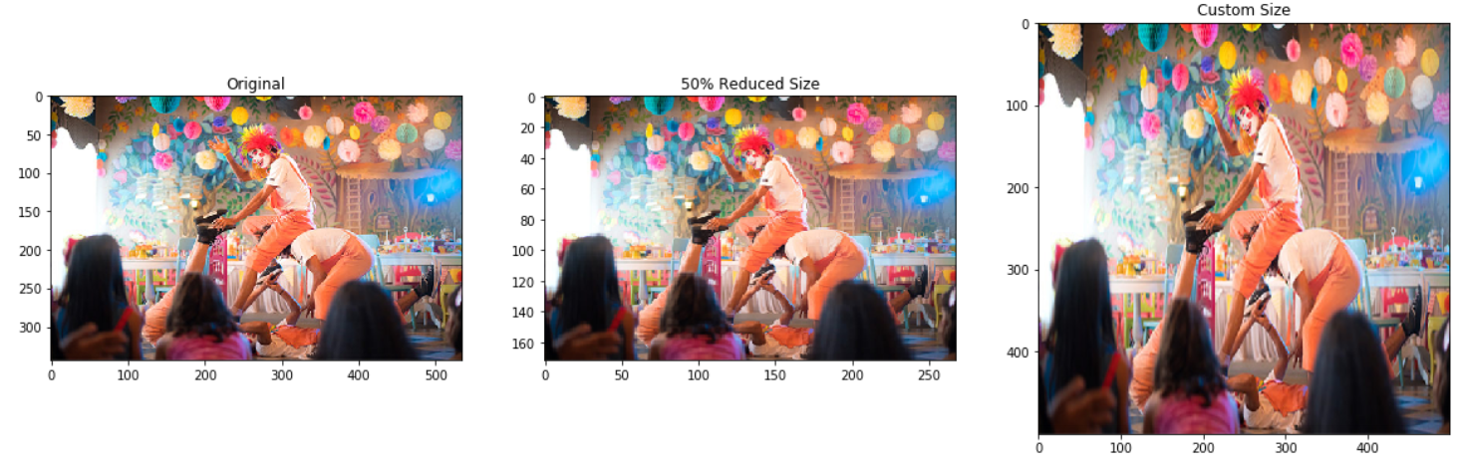

Resizing image using imutils

## Skeletonization

Skeletonization is the process of constructing the “topological skeleton” of an object in an image, where the object is presumed to be white on a black background. OpenCV does not provide a function to explicity construct the skeleton, but does provide the morphological and binary functions to do so.

For convenience, the

skeletonize

 function of

imutils

 can be used to construct the topological skeleton of the image.

The first argument,

size

 is the size of the structuring element kernel. An optional argument,

structuring

 , can be used to control the structuring element — it defaults to

cv2.MORPH_RECT

 , but can be any valid structuring element.

**NUMPY**

Top of Form

Bottom of Form

NumPy, which stands for Numerical Python, is a library consisting of multidimensional array objects and a collection of routines for processing those arrays. Using NumPy, mathematical and logical operations on arrays can be performed. This tutorial explains the basics of NumPy such as its architecture and environment. It also discusses the various array functions, types of indexing, etc. An introduction to Matplotlib is also provided. All this is explained with the help of examples for better understanding.

# Audience

This tutorial has been prepared for those who want to learn about the basics and various functions of NumPy. It is specifically useful for algorithm developers. After completing this tutorial, you will find yourself at a moderate level of expertise from where you can take yourself to higher levels of expertise.

# Prerequisites

You should have a basic understanding of computer programming terminologies. A basic understanding of Python and any of the programming languages is a plus.

NumPy is a Python package. It stands for 'Numerical Python'. It is a library consisting of multidimensional array objects and a collection of routines for processing of array.

Numeric, the ancestor of NumPy, was developed by Jim Hugunin. Another package Numarray was also developed, having some additional functionalities. In 2005, Travis Oliphant created NumPy package by incorporating the features of Numarray into Numeric package. There are many contributors to this open source project.

## Operations using NumPy

Using NumPy, a developer can perform the following operations −

* Mathematical and logical operations on arrays.
* Fourier transforms and routines for shape manipulation.
* Operations related to linear algebra. NumPy has in-built functions for linear algebra and random number generation.

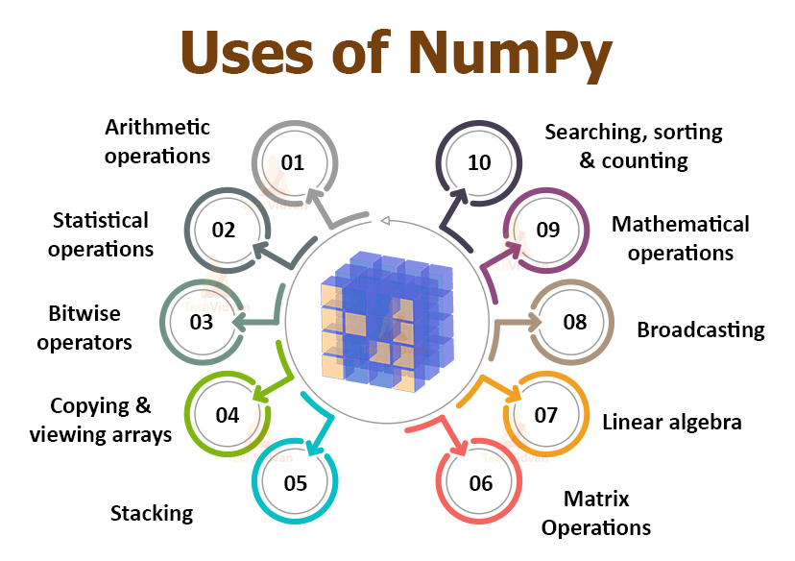

## NumPy – A Replacement for MatLab

NumPy is often used along with packages like **SciPy** (Scientific Python) and **Mat−plotlib** (plotting library). This combination is widely used as a replacement for MatLab, a popular platform for technical computing. However, Python alternative to MatLab is now seen as a more modern and complete programming language.

It is open source, which is an added advantage of NumPy.

Standard Python distribution doesn't come bundled with NumPy module. A lightweight alternative is to install NumPy using popular Python package installer, **pip**.

pip install numpy

The best way to enable NumPy is to use an installable binary package specific to your operating system. These binaries contain full SciPy stack (inclusive of NumPy, SciPy, matplotlib, IPython, SymPy and nose packages along with core Python).

## Windows

Anaconda (from [https://www.continuum.io](https://www.continuum.io/)) is a free Python distribution for SciPy stack. It is also available for Linux and Mac.

Canopy (<https://www.enthought.com/products/canopy/>) is available as free as well as commercial distribution with full SciPy stack for Windows, Linux and Mac.

Python (x,y): It is a free Python distribution with SciPy stack and Spyder IDE for Windows OS. (Downloadable from [https://www.python-xy.github.io/](https://python-xy.github.io/))

## Linux

Package managers of respective Linux distributions are used to install one or more packages in SciPy stack.

## For Ubuntu

sudo apt-get install python-numpy

python-scipy python-matplotlibipythonipythonnotebook python-pandas

python-sympy python-nose

## For Fedora

sudo yum install numpyscipy python-matplotlibipython

python-pandas sympy python-nose atlas-devel

## Building from Source

Core Python (2.6.x, 2.7.x and 3.2.x onwards) must be installed with distutils and zlib module should be enabled.

GNU gcc (4.2 and above) C compiler must be available.

To install NumPy, run the following command.

Python setup.py install

To test whether NumPy module is properly installed, try to import it from Python prompt.

import numpy

If it is not installed, the following error message will be displayed.

Traceback (most recent call last):

File "<pyshell#0>", line 1, in <module>

import numpy

ImportError: No module named 'numpy'

Alternatively, NumPy package is imported using the following syntax −

import numpy as np

**OpenCV**

OpenCV is an open-source library for the computer vision. It provides the facility to the machine to recognize the faces or objects. In this tutorial we will learn the concept of OpenCV using the Python programming language.

Our OpenCV tutorial includes all topics of Read and Save Image, Canny Edge Detection, Template matching, Blob Detection, Contour, Mouse Event, Gaussian blur and so on.

**What is OpenCV?**



OpenCV is a Python open-source library, which is used for computer vision in Artificial intelligence, Machine Learning, face recognition, etc.

In OpenCV, the CV is an abbreviation form of a computer vision, which is defined as a field of study that helps computers to understand the content of the digital images such as photographs and videos.

The purpose of computer vision is to understand the content of the images. It extracts the description from the pictures, which may be an object, a text description, and three-dimension model, and so on. For example, cars can be facilitated with computer vision, which will be able to identify and different objects around the road, such as traffic lights, pedestrians, traffic signs, and so on, and acts accordingly.

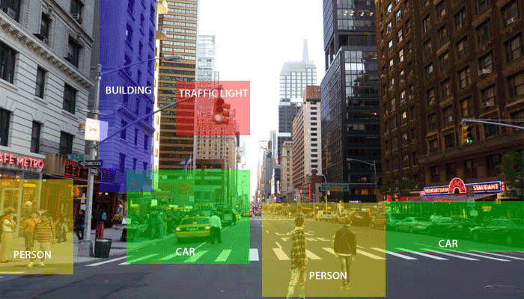

Computer vision allows the computer to perform the same kind of tasks as humans with the same efficiency. There are a two main task which are defined below:

**Object Classification -** In the object classification, we train a model on a dataset of particular objects, and the model classifies new objects as belonging to one or more of your training categories.

* **Object Identification -** In the object identification, our model will identify a particular instance of an object - for example, parsing two faces in an image and tagging one as Virat Kohli and other one as Rohit Sharma.

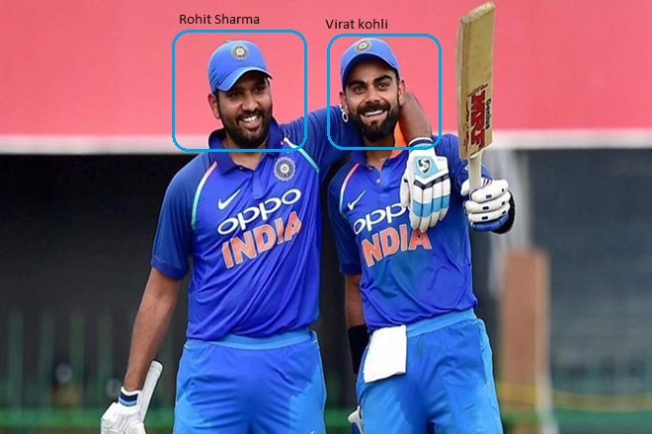

**History**

OpenCV stands for Open Source Computer Vision Library, which is widely used for image recognition or identification. It was officially launched in 1999 by Intel. It was written in C/C++ in the early stage, but now it is commonly used in Python for the computer vision as well.

The first alpha version of OpenCV was released for the common use at the IEEE Conference on Computer Vision and Pattern Recognition in 2000, and between 2001 and 2005, five betas were released. The first 1.0 version was released in 2006.

The second version of the OpenCV was released in October 2009 with the significant changes. The second version contains a major change to the C++ interface, aiming at easier, more type-safe, pattern, and better implementations. Currently, the development is done by an independent Russian team and releases its newer version in every six months.

**How OpenCV Works**

In this tutorial, we will learn how computers perform image recognition.

**How does computer recognize the image?**

Human eyes provide lots of information based on what they see. Machines are facilitated with seeing everything, convert the vision into numbers and store in the memory. Here the question arises how computer convert images into numbers. So the answer is that the pixel value is used to convert images into numbers. A pixel is the smallest unit of a digital image or graphics that can be displayed and represented on a digital display device.

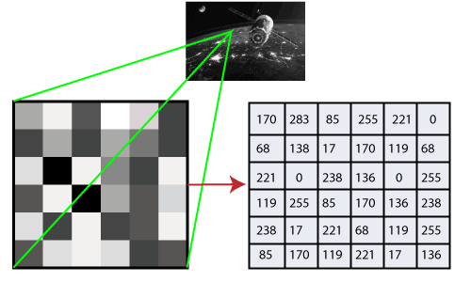

The picture intensity at the particular location is represented by the numbers. In the above image, we have shown the pixel values for a grayscale image consist of only one value, the intensity of the black color at that location.

There are two common ways to identify the images:

**1. Grayscale**

Grayscale images are those images which contain only two colors black and white. The contrast measurement of intensity is black treated as the weakest intensity, and white as the strongest intensity. When we use the grayscale image, the computer assigns each pixel value based on its level of darkness.

**2. RGB**

An RGB is a combination of the red, green, blue color which together makes a new color. The computer retrieves that value from each pixel and puts the results in an array to be interpreted.

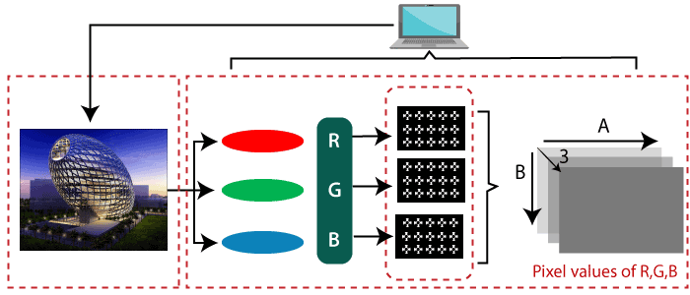

**Why OpenCV is used for Computer Vision?**

* OpenCV is available for free of cost.
* Since the OpenCV library is written in C/C++, so it is quit fast. Now it can be used with Python.
* It require less RAM to usage, it maybe of 60-70 MB.
* Computer Vision is portable as OpenCV and can run on any device that can run on C.

**Prerequisite**

Before learning OpenCV, you must have the basic knowledge of Python programming language.

**Audience**

Our OpenCV tutorial is designed to help beginners and professionals.

**MATPLOTLIB**

Top of Form

Bottom of Form

Matplotlib is one of the most popular Python packages used for data visualization. It is a cross-platform library for making 2D plots from data in arrays. It provides an object-oriented API that helps in embedding plots in applications using Python GUI toolkits such as PyQt, WxPythonotTkinter. It can be used in Python and IPython shells, Jupyter notebook and web application servers also.

# Audience

This tutorial is designed for those learners who wish to acquire knowledge on the basics of data visualization.

# Prerequisites

Matplotlib is written in Python and makes use of NumPy, the numerical mathematics extension of Python. We assume that the readers of this tutorial have basic knowledge of Python.

Matplotlib is one of the most popular Python packages used for data visualization. It is a cross-platform library for making 2D plots from data in arrays. Matplotlib is written in Python and makes use of NumPy, the numerical mathematics extension of Python. It provides an object-oriented API that helps in embedding plots in applications using Python GUI toolkits such as PyQt, WxPythonotTkinter. It can be used in Python and IPython shells, Jupyter notebook and web application servers also.

Matplotlib has a procedural interface named the Pylab, which is designed to resemble MATLAB, a proprietary programming language developed by MathWorks. Matplotlib along with NumPy can be considered as the open source equivalent of MATLAB.

Matplotlib was originally written by John D. Hunter in 2003. The current stable version is 2.2.0 released in January 2018.

Matplotlib and its dependency packages are available in the form of wheel packages on the standard Python package repositories and can be installed on Windows, Linux as well as MacOS systems using the pip package manager.

pip3 install matplotlib

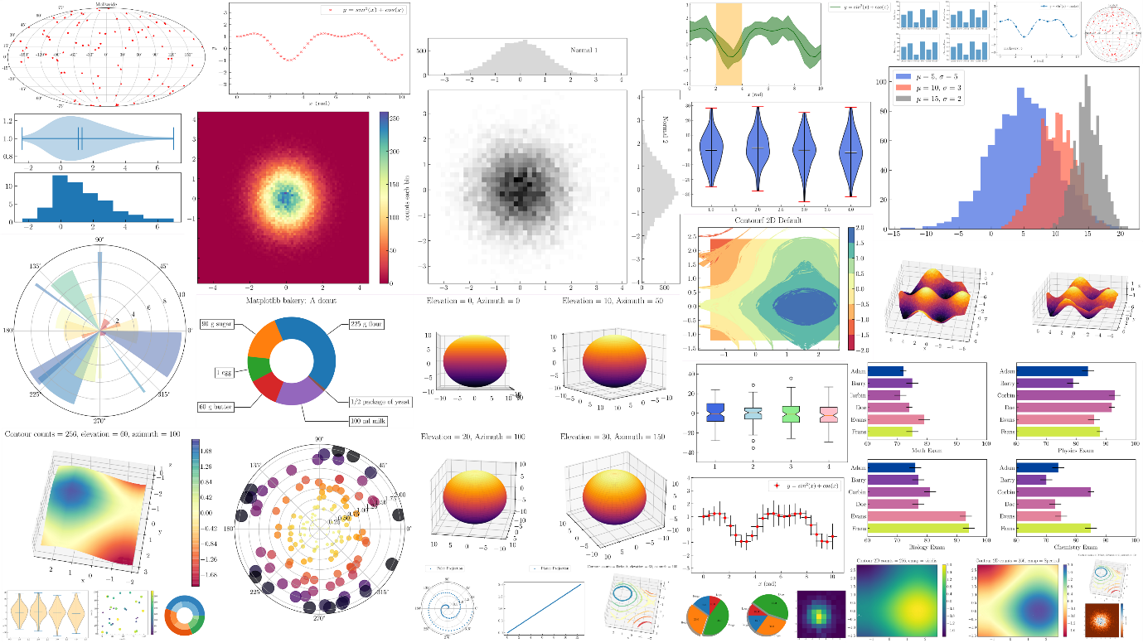

Various types of plot generated in Matplotlib

Incase Python 2.7 or 3.4 versions are not installed for all users, the Microsoft Visual C++ 2008 (64 bit or 32 bit forPython 2.7) or Microsoft Visual C++ 2010 (64 bit or 32 bit for Python 3.4) redistributable packages need to be installed.

If you are using Python 2.7 on a Mac, execute the following command −

xcode-select –install

Upon execution of the above command, the subprocess32 - a dependency, may be compiled.

On extremely old versions of Linux and Python 2.7, you may need to install the master version of subprocess32.

Matplotlib requires a large number of dependencies −

* Python (>= 2.7 or >= 3.4)
* NumPy
* setuptools
* dateutil
* pyparsing
* libpng
* pytz
* FreeType
* cycler
* six

Optionally, you can also install a number of packages to enable better user interface toolkits.

* tk
* PyQt4
* PyQt5
* pygtk
* wxpython
* pycairo
* Tornado

For better support of animation output format and image file formats, LaTeX, etc., you can install the following −

* _mpeg/avconv
* ImageMagick
* Pillow (>=2.0)
* LaTeX and GhostScript (for rendering text with LaTeX).

LaTeX and GhostScript (for rendering text with LaTeX).

**SciPy**

Top of Form

Bottom of Form

SciPy, a scientific library for Python is an open source, BSD-licensed library for mathematics, science and engineering. The SciPy library depends on NumPy, which provides convenient and fast N-dimensional array manipulation. The main reason for building the SciPy library is that, it should work with NumPy arrays. It provides many user-friendly and efficient numerical practices such as routines for numerical integration and optimization. This is an introductory tutorial, which covers the fundamentals of SciPy and describes how to deal with its various modules.

# Audience

This tutorial is prepared for the readers, who want to learn the basic features along with the various functions of SciPy. After completing this tutorial, the readers will find themselves at a moderate level of expertise, from where they can take themselves to higher levels of expertise.

# Prerequisites

Before proceeding with the various concepts given in this tutorial, it is being expected that the readers have a basic understanding of Python. In addition to this, it will be very helpful, if the readers have some basic knowledge of other programming languages. SciPy library depends on the NumPy library, hence learning the basics of NumPy makes the understanding easy.

SciPy, pronounced as Sigh Pi, is a scientific python open source, distributed under the BSD licensed library to perform Mathematical, Scientific and Engineering Computations.

The SciPy library depends on NumPy, which provides convenient and fast N-dimensional array manipulation. The SciPy library is built to work with NumPy arrays and provides many user-friendly and efficient numerical practices such as routines for numerical integration and optimization. Together, they run on all popular operating systems, are quick to install and are free of charge. NumPy and SciPy are easy to use, but powerful enough to depend on by some of the world's leading scientists and engineers.

## SciPy Sub-packages

SciPy is organized into sub-packages covering different scientific computing domains. These are summarized in the following table −

|  |  |
| --- | --- |
| [scipy.cluster](https://docs.scipy.org/doc/scipy/reference/cluster.html#module-scipy.cluster) | Vector quantization / Kmeans |
| [scipy.constants](https://docs.scipy.org/doc/scipy/reference/constants.html#module-scipy.constants) | Physical and mathematical constants |
| [scipy.fftpack](https://docs.scipy.org/doc/scipy/reference/fftpack.html#module-scipy.fftpack) | Fourier transform |
| [scipy.integrate](https://docs.scipy.org/doc/scipy/reference/integrate.html#module-scipy.integrate) | Integration routines |
| [scipy.interpolate](https://docs.scipy.org/doc/scipy/reference/interpolate.html#module-scipy.interpolate) | Interpolation |
| [scipy.io](https://docs.scipy.org/doc/scipy/reference/io.html#module-scipy.io) | Data input and output |
| [scipy.linalg](https://docs.scipy.org/doc/scipy/reference/linalg.html#module-scipy.linalg) | Linear algebra routines |
| [scipy.ndimage](https://docs.scipy.org/doc/scipy/reference/ndimage.html#module-scipy.ndimage) | n-dimensional image package |
| [scipy.odr](https://docs.scipy.org/doc/scipy/reference/odr.html#module-scipy.odr) | Orthogonal distance regression |
| [scipy.optimize](https://docs.scipy.org/doc/scipy/reference/optimize.html#module-scipy.optimize) | Optimization |
| [scipy.signal](https://docs.scipy.org/doc/scipy/reference/signal.html#module-scipy.signal) | Signal processing |
| [scipy.sparse](https://docs.scipy.org/doc/scipy/reference/sparse.html#module-scipy.sparse) | Sparse matrices |
| [scipy.spatial](https://docs.scipy.org/doc/scipy/reference/spatial.html#module-scipy.spatial) | Spatial data structures and algorithms |
| [scipy.special](https://docs.scipy.org/doc/scipy/reference/special.html#module-scipy.special) | Any special mathematical functions |
| [scipy.stats](https://docs.scipy.org/doc/scipy/reference/stats.html#module-scipy.stats) | Statistics |

## 

## Data Structure

The basic data structure used by SciPy is a multidimensional array provided by the NumPy module. NumPy provides some functions for Linear Algebra, Fourier Transforms and Random Number Generation, but not with the generality of the equivalent functions in SciPy.

Standard Python distribution does not come bundled with any SciPy module. A lightweight alternative is to install SciPy using the popular Python package installer,

pip install pandas

If we install the Anaconda Python package, Pandas will be installed by default. Following are the packages and links to install them in different operating systems.

## Windows

**Anaconda** (from [https://www.continuum.io](https://www.continuum.io/)) is a free Python distribution for the SciPy stack. It is also available for Linux and Mac.

**Canopy** (<https://www.enthought.com/products/canopy/>) is available free, as well as for commercial distribution with a full SciPy stack for Windows, Linux and Mac.

**Python (x,y)** − It is a free Python distribution with SciPy stack and Spyder IDE for Windows OS. (Downloadable from <https://python-xy.github.io/>)

### Linux

Package managers of respective Linux distributions are used to install one or more packages in the SciPy stack.

### Ubuntu

We can use the following path to install Python in Ubuntu.

sudo apt-get install python-numpy python-scipy

python-matplotlibipythonipython-notebook python-pandas python-sympy python-nose

### Fedora

We can use the following path to install Python in Fedora.

sudo yum install numpyscipy python-matplotlibipython python-pandas

sympy python-nose atlas-devel

**Face-Mask-Detection-Master**

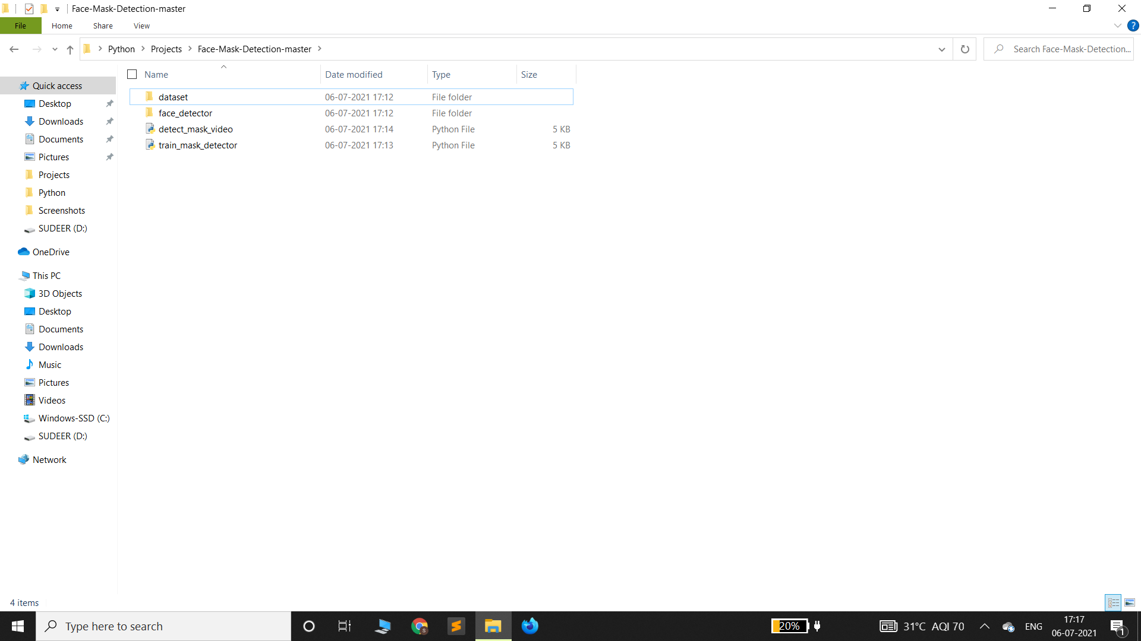

This Face-Mask-Detection-Master consists of a dataset, face_detector folders and train_mask_detector, detect_mask_video and python files.

**DATASET**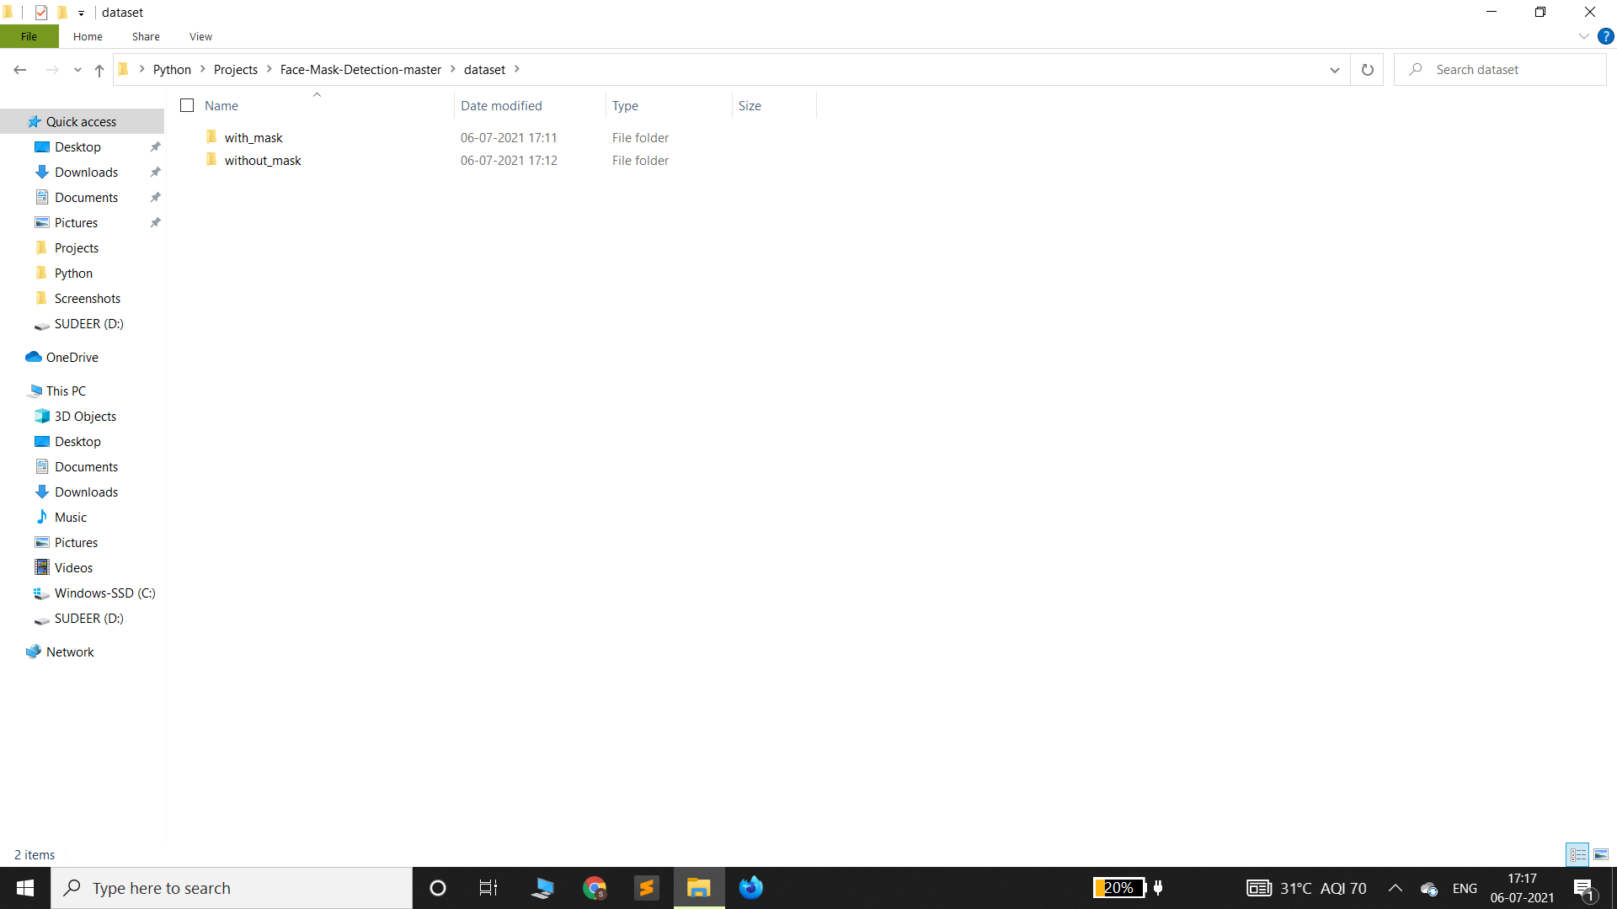

The dataset consists of two folders with_mask and without_mask which are taken from some open source websites.

**With_Mask**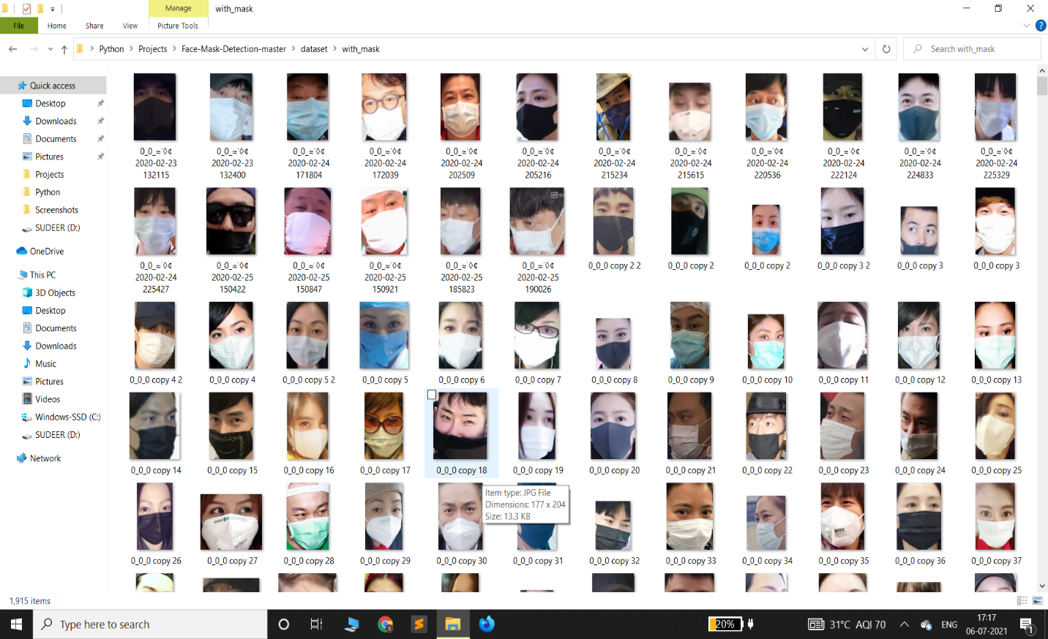

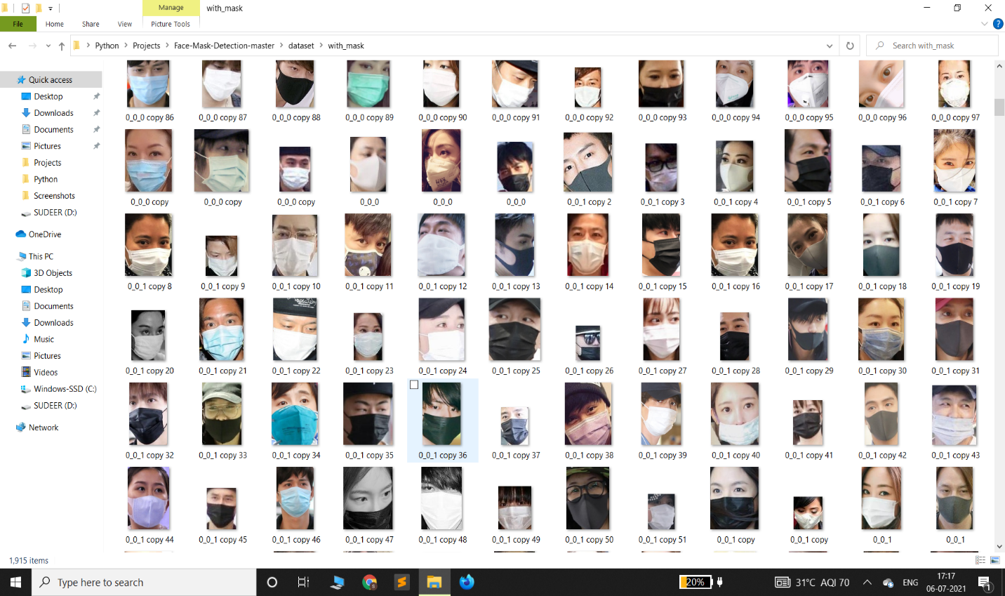

The with_mask folder consists of images with mask.

**Without_Mask**

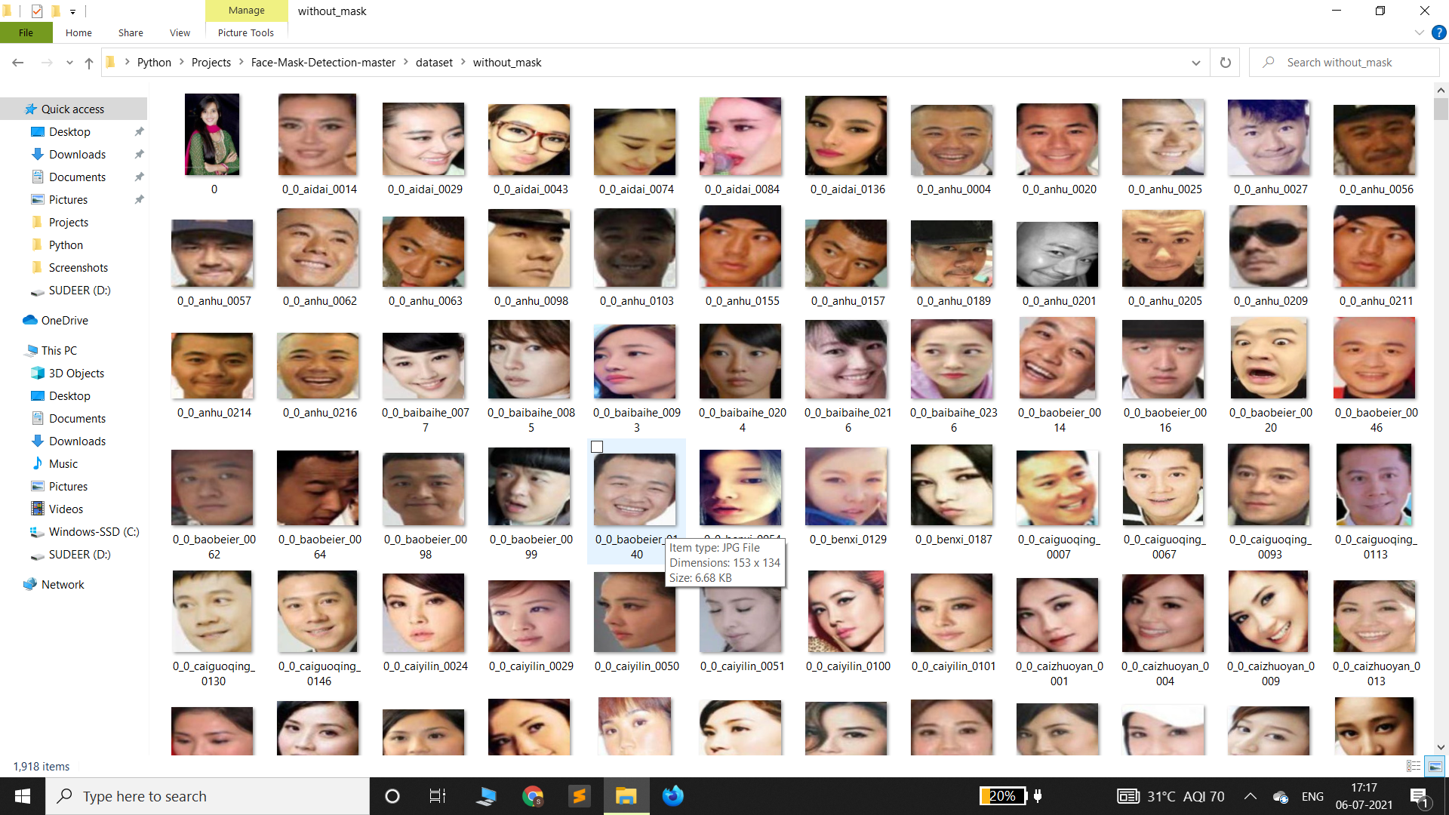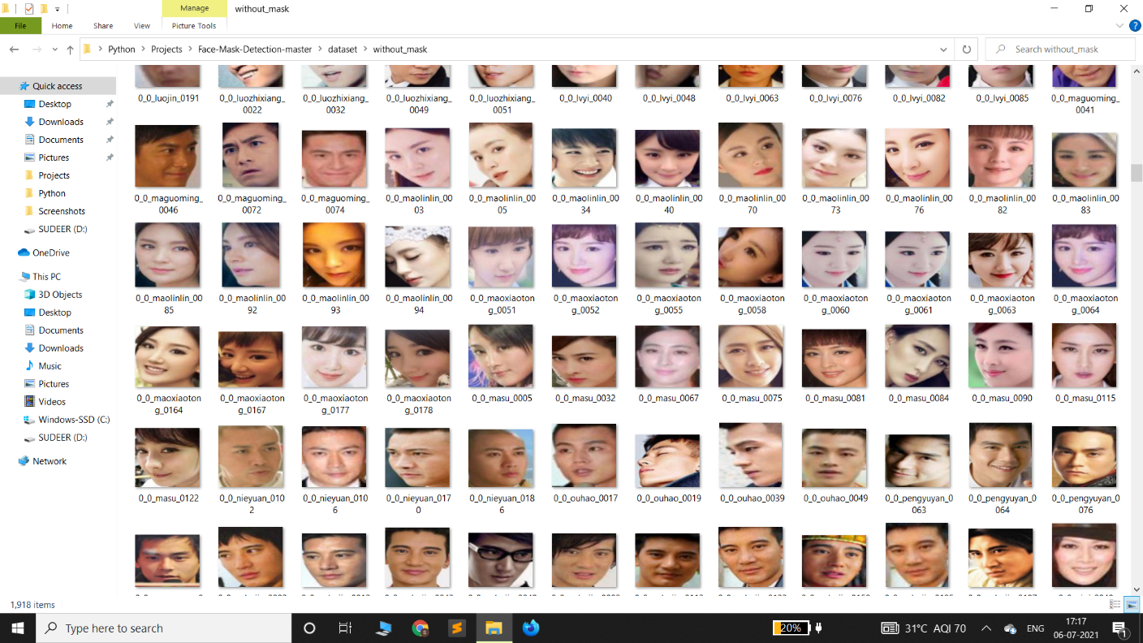

The without_mask folder consists of images without mask.

**Face_Detector** 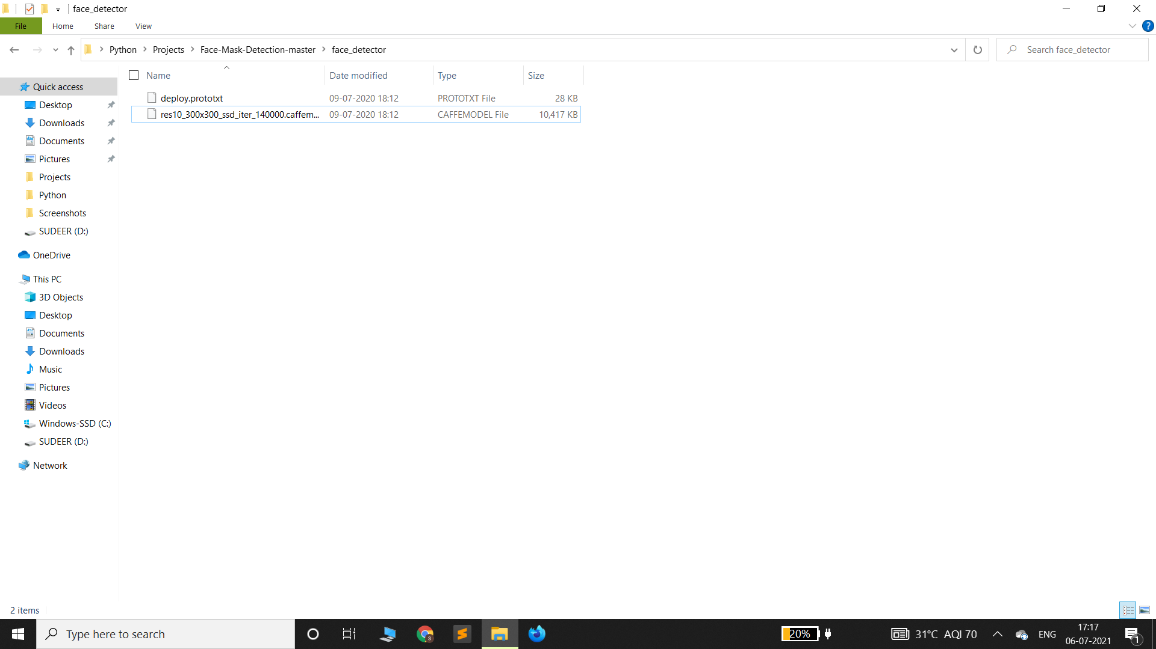

The face_detector folder consists of two files which helps to detect the face.

**CODING**

Train_Mask_Detector.py

# import the necessary packages

from tensorflow.keras.preprocessing.image import ImageDataGenerator

from tensorflow.keras.applications import MobileNetV2

from tensorflow.keras.layers import AveragePooling2D

from tensorflow.keras.layers import Dropout

from tensorflow.keras.layers import Flatten

from tensorflow.keras.layers import Dense

from tensorflow.keras.layers import Input

from tensorflow.keras.models import Model

from tensorflow.keras.optimizers import Adam

from tensorflow.keras.applications.mobilenet_v2 import preprocess_input

from tensorflow.keras.preprocessing.image import img_to_array

from tensorflow.keras.preprocessing.image import load_img

from tensorflow.keras.utils import to_categorical

from sklearn.preprocessing import LabelBinarizer

from sklearn.model_selection import train_test_split

from sklearn.metrics import classification_report

from imutils import paths

import matplotlib.pyplot as plt

import numpy as np

import os

# initialize the initial learning rate, number of epochs to train for,

# and batch size

INIT_LR = 1e-4

EPOCHS = 20

BS = 32

DIRECTORY = r"C:\Users\sudca\Desktop\Python\Projects\Face-Mask-Detection-master\dataset"

CATEGORIES = ["with_mask", "without_mask"]

# grab the list of images in our dataset directory, then initialize

# the list of data (i.e., images) and class images

print("[INFO] loading images...")

data = []

labels = []

for category in CATEGORIES:

path = os.path.join(DIRECTORY, category)

for img in os.listdir(path):

img_path = os.path.join(path, img)

image = load_img(img_path, target_size=(224, 224))

image = img_to_array(image)

image = preprocess_input(image)

data.append(image)

labels.append(category)

# perform one-hot encoding on the labels

lb = LabelBinarizer()

labels = lb.fit_transform(labels)

labels = to_categorical(labels)

data = np.array(data, dtype="float32")

labels = np.array(labels)

(trainX, testX, trainY, testY) = train_test_split(data, labels,

test_size=0.20, stratify=labels, random_state=42)

# construct the training image generator for data augmentation

aug = ImageDataGenerator(

rotation_range=20,

zoom_range=0.15,

width_shift_range=0.2,

height_shift_range=0.2,

shear_range=0.15,

horizontal_flip=True,

fill_mode="nearest")

# load the MobileNetV2 network, ensuring the head FC layer sets are

# left off

baseModel = MobileNetV2(weights="imagenet", include_top=False,

input_tensor=Input(shape=(224, 224, 3)))

# construct the head of the model that will be placed on top of the

# the base model

headModel = baseModel.output

headModel = AveragePooling2D(pool_size=(7, 7))(headModel)

headModel = Flatten(name="flatten")(headModel)

headModel = Dense(128, activation="relu")(headModel)

headModel = Dropout(0.5)(headModel)

headModel = Dense(2, activation="softmax")(headModel)

# place the head FC model on top of the base model (this will become

# the actual model we will train)

model = Model(inputs=baseModel.input, outputs=headModel)

# loop over all layers in the base model and freeze them so they will

# *not* be updated during the first training process

for layer in baseModel.layers:

layer.trainable = False

# compile our model

print("[INFO] compiling model...")

opt = Adam(lr=INIT_LR, decay=INIT_LR / EPOCHS)

model.compile(loss="binary_crossentropy", optimizer=opt,

metrics=["accuracy"])

# train the head of the network

print("[INFO] training head...")

H = model.fit(

aug.flow(trainX, trainY, batch_size=BS),

steps_per_epoch=len(trainX) // BS,

validation_data=(testX, testY),

validation_steps=len(testX) // BS,

epochs=EPOCHS)

# make predictions on the testing set

print("[INFO] evaluating network...")

predIdxs = model.predict(testX, batch_size=BS)

# for each image in the testing set we need to find the index of the

# label with corresponding largest predicted probability

predIdxs = np.argmax(predIdxs, axis=1)

# show a nicely formatted classification report

print(classification_report(testY.argmax(axis=1), predIdxs,

target_names=lb.classes_))

# serialize the model to disk

print("[INFO] saving mask detector model...")

model.save("mask_detector.model", save_format="h5")

# plot the training loss and accuracy

N = EPOCHS

plt.style.use("ggplot")

plt.figure()

plt.plot(np.arange(0, N), H.history["loss"], label="train_loss")

plt.plot(np.arange(0, N), H.history["val_loss"], label="val_loss")

plt.plot(np.arange(0, N), H.history["accuracy"], label="train_acc")

plt.plot(np.arange(0, N), H.history["val_accuracy"], label="val_acc")

plt.title("Training Loss and Accuracy")

plt.xlabel("Epoch #")

plt.ylabel("Loss/Accuracy")

plt.legend(loc="lower left")

plt.savefig("plot.png")

train_mask_detector.py file is used to develop a machine learning model by converting the dataset folder with and without mask images into arrays. Make sure that the path must be given within double quotes within this code. And that path must locate the dataset which contain images with and without masks.

**Training Machine Learning Model**

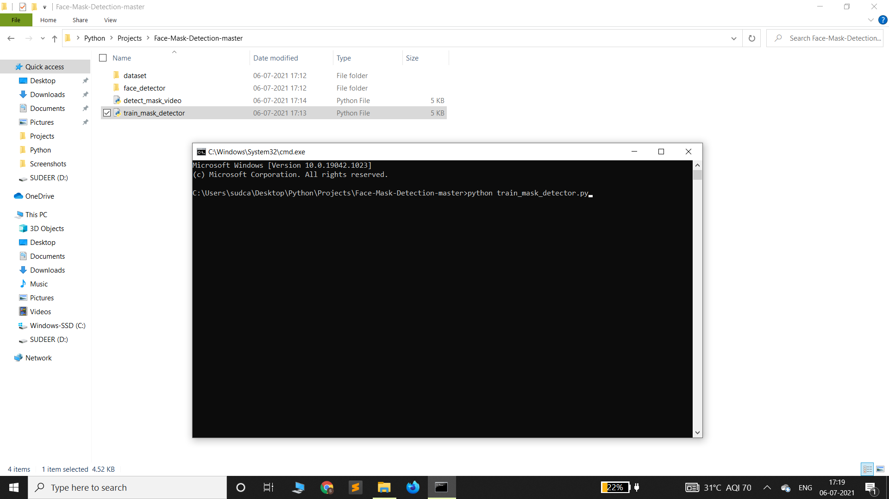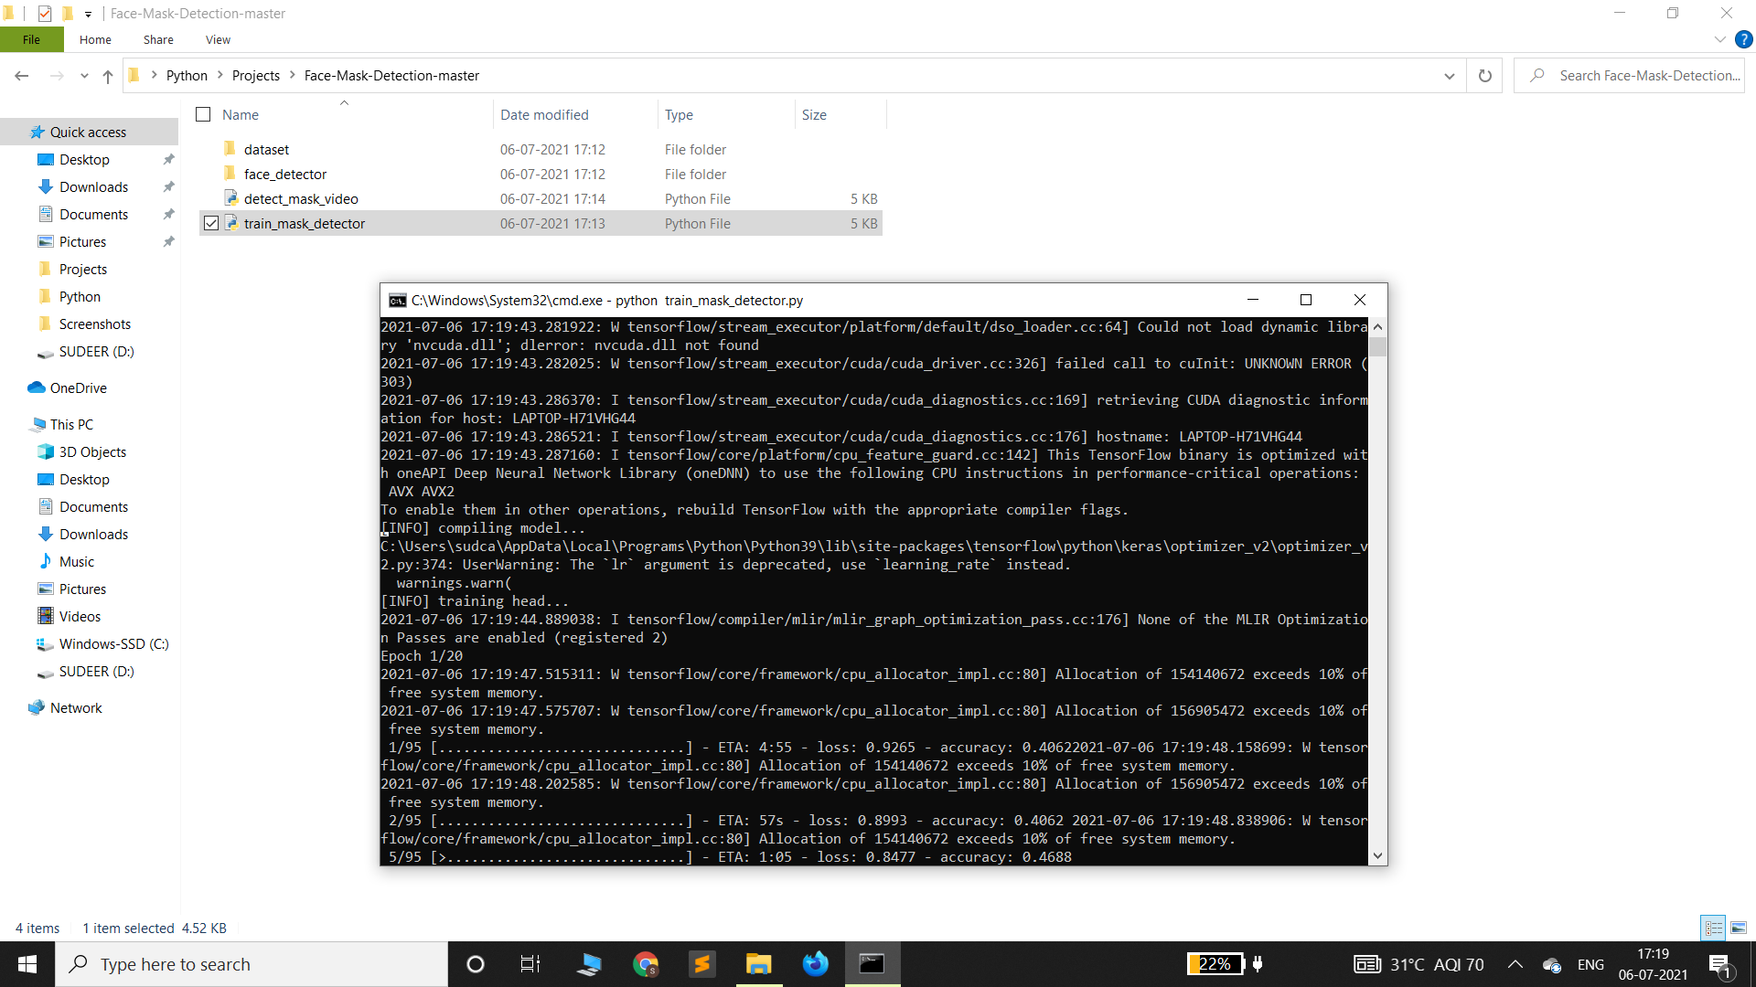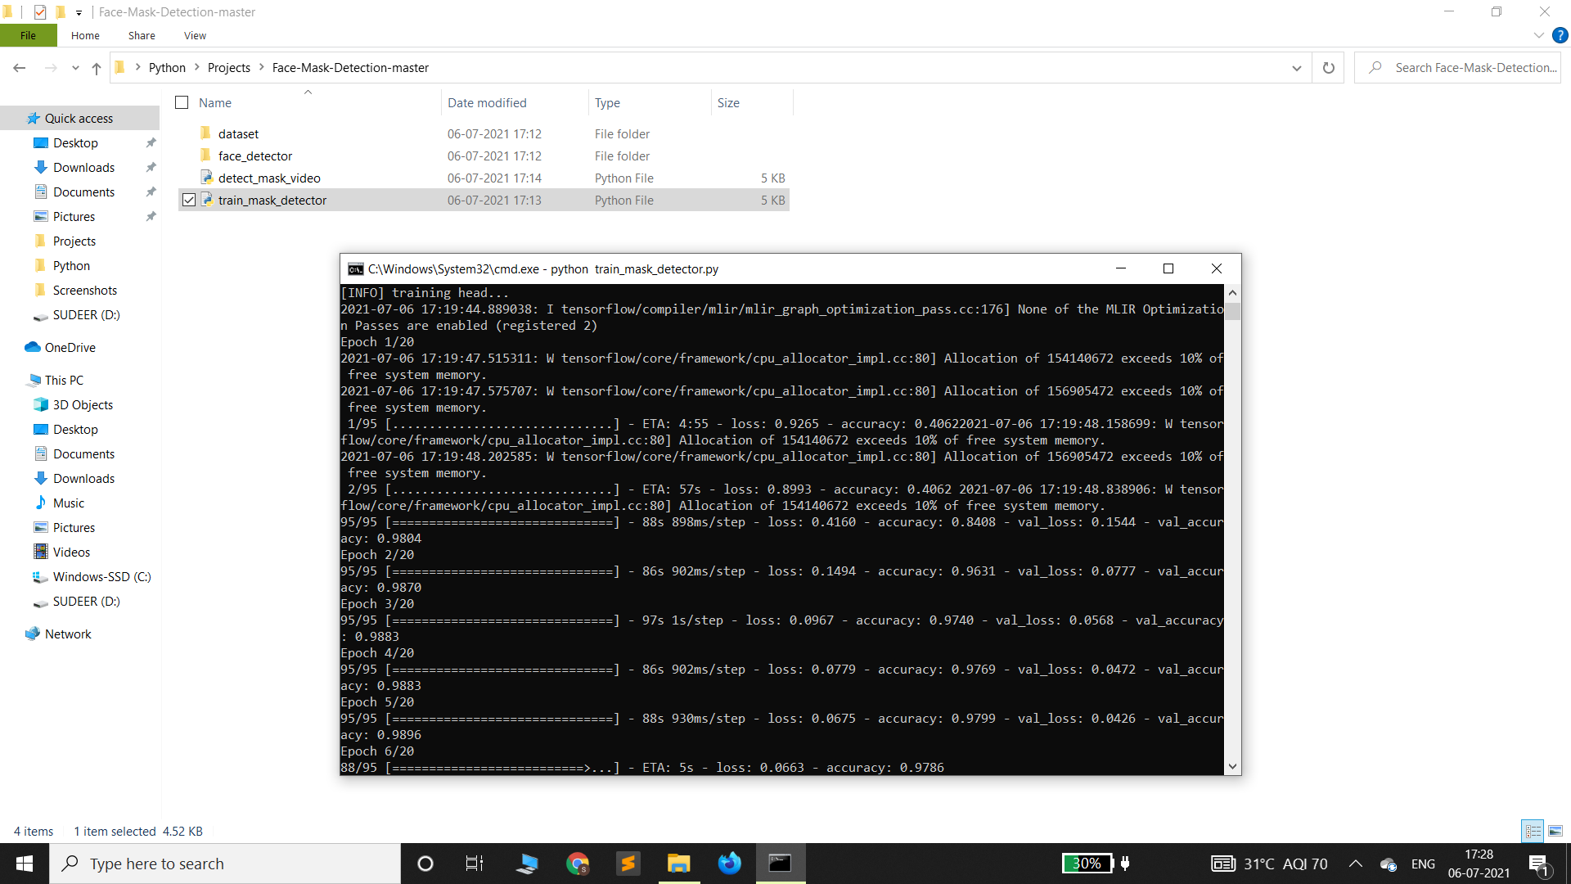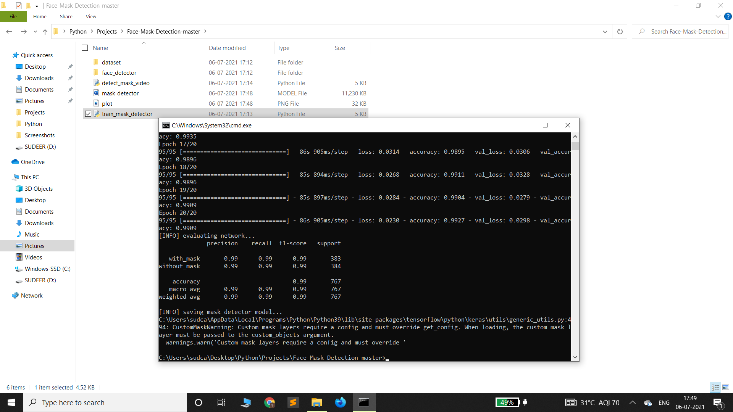

train_mask_detector file is executed to train the dataset into machine learning model then a machine learning model and a plot is generated.

**Training And Loss Accuracy**

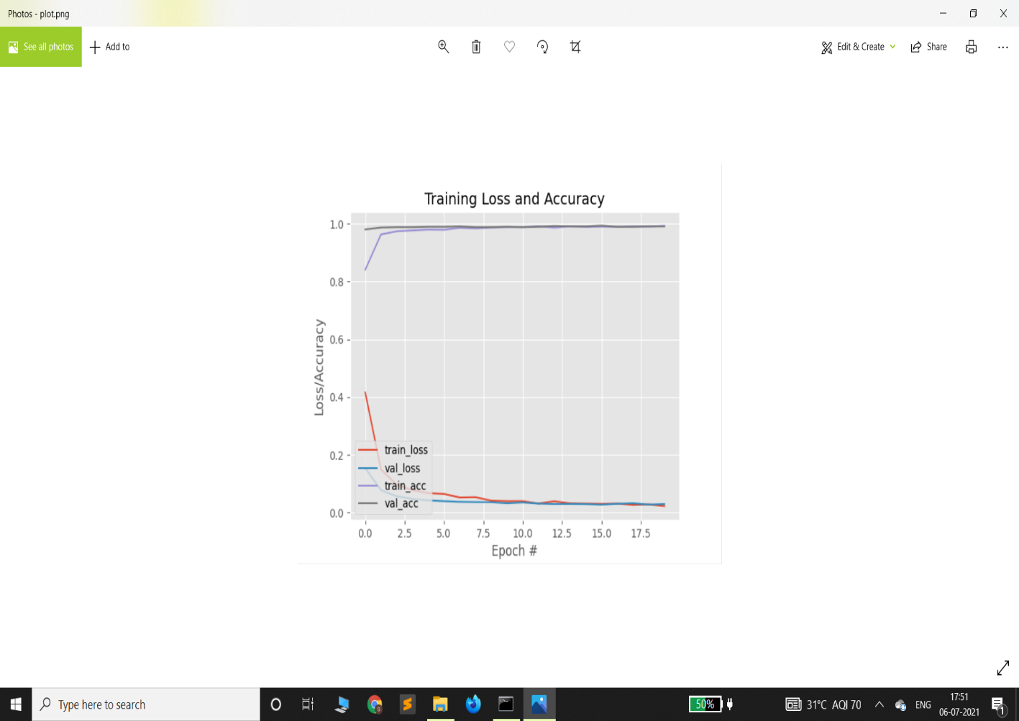

This plot is to show a graphical representation of training the machine learning model.

Detect_Mask_Video.py

# import the necessary packages

from tensorflow.keras.applications.mobilenet_v2 import preprocess_input

from tensorflow.keras.preprocessing.image import img_to_array

from tensorflow.keras.models import load_model

from imutils.video import VideoStream

import numpy as np

import imutils

import time

import cv2

import os

def detect_and_predict_mask(frame, faceNet, maskNet):

# grab the dimensions of the frame and then construct a blob

# from it

(h, w) = frame.shape[:2]

blob = cv2.dnn.blobFromImage(frame, 1.0, (224, 224),

(104.0, 177.0, 123.0))

# pass the blob through the network and obtain the face detections

faceNet.setInput(blob)

detections = faceNet.forward()

print(detections.shape)

# initialize our list of faces, their corresponding locations,

# and the list of predictions from our face mask network

faces = []

locs = []

preds = []

# loop over the detections

for i in range(0, detections.shape[2]):

# extract the confidence (i.e., probability) associated with

# the detection

confidence = detections[0, 0, i, 2]

# filter out weak detections by ensuring the confidence is

# greater than the minimum confidence

if confidence > 0.5:

# compute the (x, y)-coordinates of the bounding box for

# the object

box = detections[0, 0, i, 3:7] * np.array([w, h, w, h])

(startX, startY, endX, endY) = box.astype("int")

# ensure the bounding boxes fall within the dimensions of

# the frame

(startX, startY) = (max(0, startX), max(0, startY))

(endX, endY) = (min(w - 1, endX), min(h - 1, endY))

# extract the face ROI, convert it from BGR to RGB channel

# ordering, resize it to 224x224, and preprocess it

face = frame[startY:endY, startX:endX]

face = cv2.cvtColor(face, cv2.COLOR_BGR2RGB)

face = cv2.resize(face, (224, 224))

face = img_to_array(face)

face = preprocess_input(face)

# add the face and bounding boxes to their respective

# lists

faces.append(face)

locs.append((startX, startY, endX, endY))

# only make a predictions if at least one face was detected

if len(faces) > 0:

# for faster inference we'll make batch predictions on *all*

# faces at the same time rather than one-by-one predictions

# in the above `for` loop

faces = np.array(faces, dtype="float32")

preds = maskNet.predict(faces, batch_size=32)

# return a 2-tuple of the face locations and their corresponding

# locations

return (locs, preds)

# load our serialized face detector model from disk

prototxtPath = r"face_detector\deploy.prototxt"

weightsPath = r"face_detector\res10_300x300_ssd_iter_140000.caffemodel"

faceNet = cv2.dnn.readNet(prototxtPath, weightsPath)

# load the face mask detector model from disk

maskNet = load_model("mask_detector.model")

# initialize the video stream

print("[INFO] starting video stream...")

vs = VideoStream(src=0).start()

# loop over the frames from the video stream

while True:

# grab the frame from the threaded video stream and resize it

# to have a maximum width of 400 pixels

frame = vs.read()

frame = imutils.resize(frame, width=400)

# detect faces in the frame and determine if they are wearing a

# face mask or not

(locs, preds) = detect_and_predict_mask(frame, faceNet, maskNet)

# loop over the detected face locations and their corresponding

# locations

for (box, pred) in zip(locs, preds):

# unpack the bounding box and predictions

(startX, startY, endX, endY) = box

(mask, withoutMask) = pred

# determine the class label and color we'll use to draw

# the bounding box and text

label = "Mask" if mask > withoutMask else "No Mask"

color = (0, 255, 0) if label == "Mask" else (0, 0, 255)

# include the probability in the label

label = "{}: {:.2f}%".format(label, max(mask, withoutMask) * 100)

# display the label and bounding box rectangle on the output

# frame

cv2.putText(frame, label, (startX, startY - 10),

cv2.FONT_HERSHEY_SIMPLEX, 0.45, color, 2)

cv2.rectangle(frame, (startX, startY), (endX, endY), color, 2)

# show the output frame

cv2.imshow("Frame", frame)

key = cv2.waitKey(1) & 0xFF

# if the `q` key was pressed, break from the loop

if key == ord("q"):

break

# do a bit of cleanup

cv2.destroyAllWindows()

vs.stop()

detect_mask_video.py file detects weather certain person is wearing a face mask or not showing with percentage of it.

**Detect_Mask _Video.py**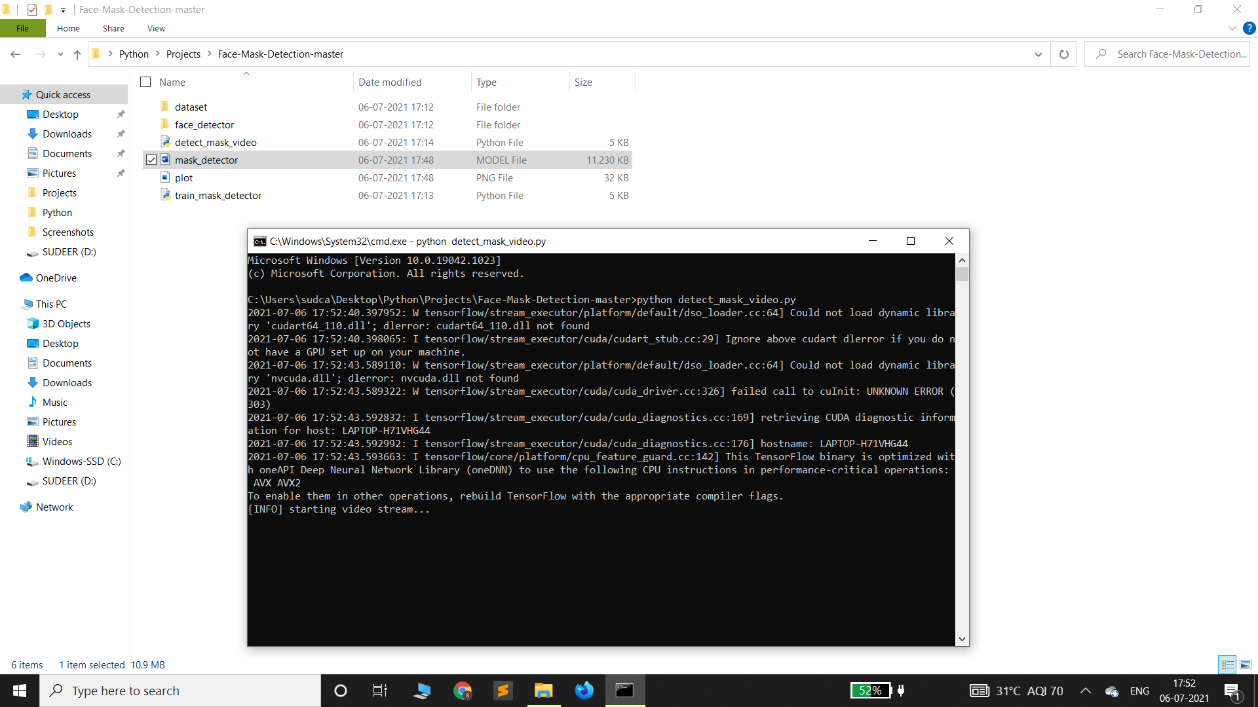

detect_mask_video file is executed for detecting weather certain person is wearing a face mask or not with percentage on it.

**INPUT**

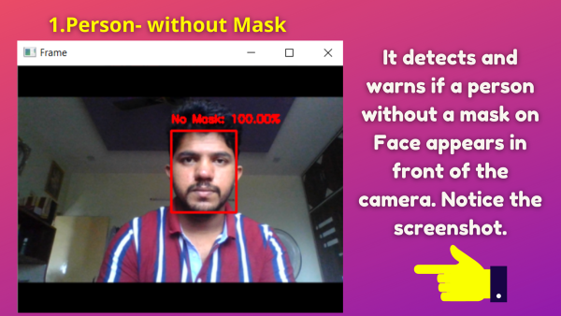

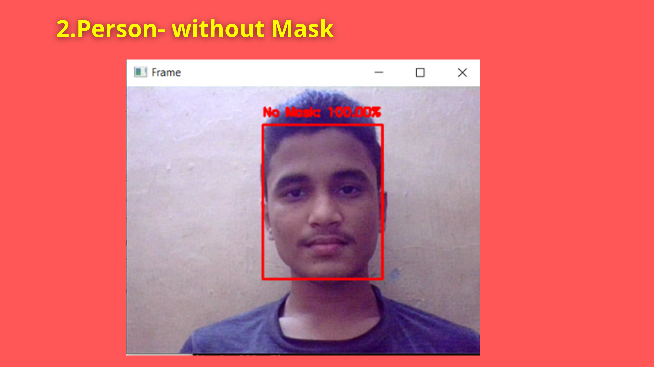

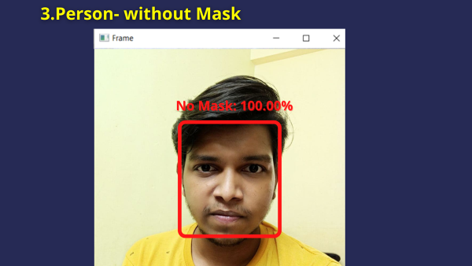

**OUTPUT**

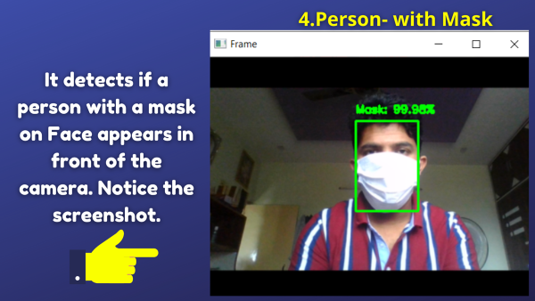

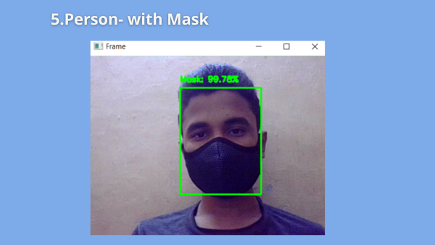

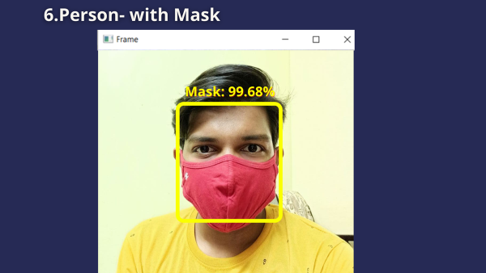

**RESULT ANALYSIS**

By preserving a reasonable proportion of different classes, the dataset is partitioned into training and set. The dataset comprises of 1915 samples with facemask and 1918 samples without facemask in total where 3883 samples which are used in training phase. The developed architecture is trained for 10 epochs since further training results cause overfitting on the training data. Overfitting generally occurs when a model learns the unwanted patterns of the training samples. Hence, training accuracy increases but test accuracy decreases. Training and loss accuracy figure shows the graphical view of accuracy and loss respectively. The trained model showed 95% accuracy.

**LIMITATIONS AND FURTHER WORKS**

The developed system can detect the live video streams but does not keep a record. Unlike the CCTV camera footage, the admin cannot rewind, play or pause it. As whenever a strict system is imposed people always try to break it. Hence when a person is detected with no mask, the head of the organization can be notified via mail that so and so person entered without mask. The proposed system can be integrated with databases of respective organizations to keep a record of the person who entered without mask. With more complex functions a screenshot of the person’s face can also be attached to keep it as a proof.

**CONCLUSION**

As the technology is booming with emerging trends therefore the novel real-time facemask detection can possibly contribute to public healthcare. The model is trained on an authentic dataset. We used OpenCV, tensor flow, keras, imutils, numpy, matplotlib and scipy libraries to detect whether people were wearing face masks or not. The models were tested with images and real-time video. The accuracy of the model is achieved and, the optimization of the model is a continuous process and we are building an accurate solution by tuning the hyper parameters. This specific model could be used as a use case for edge analytics. By the developing this system, we can detect if the person is wearing a face mask and allow their entry would be of great help to the society.

**BIBLIOGRAPHY**

**BOOKS REFERRED**

1.Python-The Complete Reference (Martin C. Brown)

2.Machine Learning Using Python (U Dinesh Kumar)

**WEBSITES REFERRED**

1. <https://www.google.com/>

2. <https://www.youtube.com/>

3. <https://www.python-course.eu/machine_learning.php>

4. <https://stackoverflow.com/>

5. <https://www.geeksforgeeks.org/best-python-libraries-for-machinelearning/>